I first opened my champlain virtual machine on my home device and went to fw01-SYS-255-01-connor.east. From there I only had one network adapter named “SYS-255-01-WAN”. Next, I clicked “add new device” and inserted a new network adapter connected to SYS-255-01-LAN-connor.east

The Mac Address for each is as follows:

SYS-255-01-WAN —-> 00:50:56:a1:82:01

SYS-255-01-LAN-connor.east —-----> 00:50:56:a1:f8:6d

Below is an image of said section

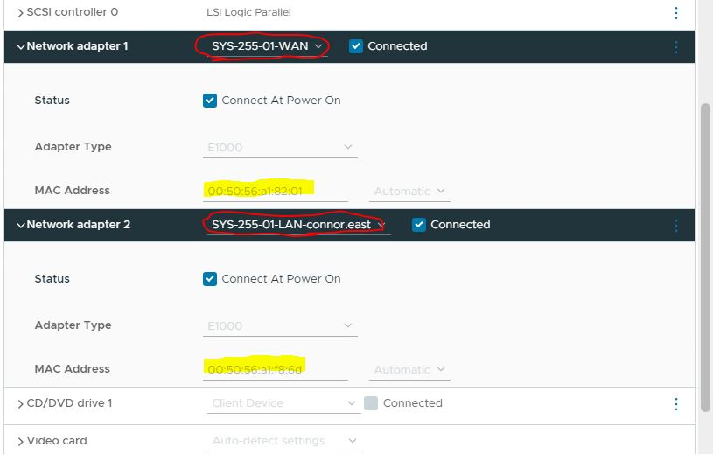

Next I right clicked on the firewall in order to start it. From there I opened it in a secondary window. Once the loading process had finished I typed 1 and then assigned the LAN to em1 and theWAN to em0 as seen in the picture below

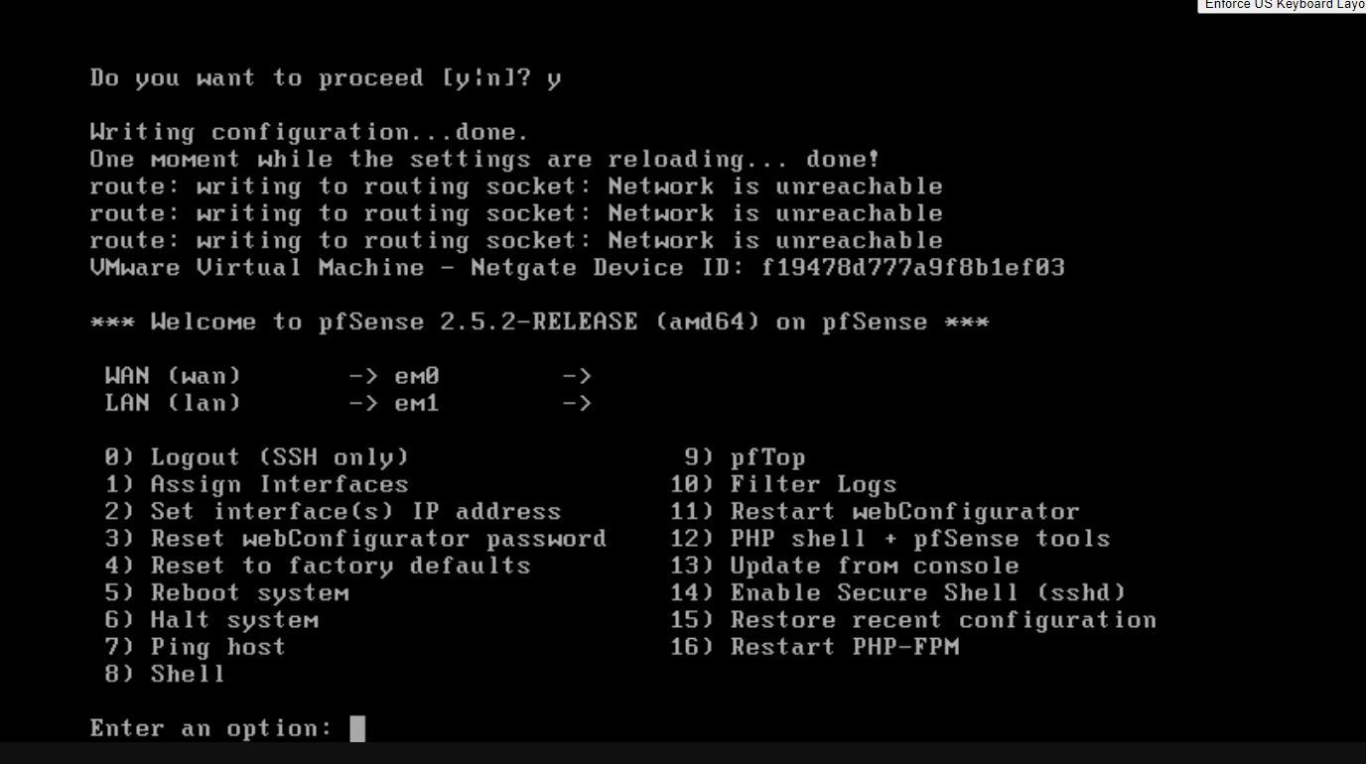

Next I choose option 2 (Set interfaces IP address) before selecting 1 for WAN and going through the setup process of setting its v4 to 10.0.17.106. I then repeated the setup steps for the LAN selecting 2 instead.

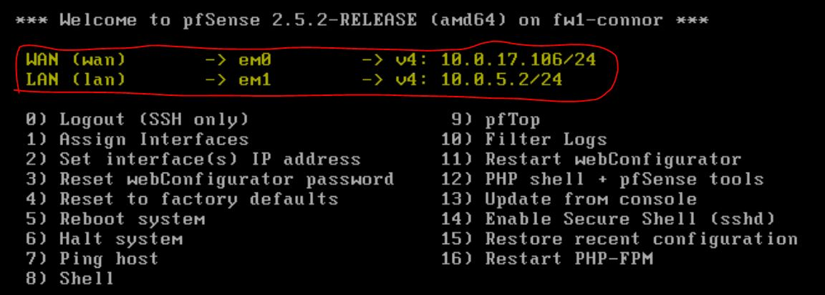

As you can see in the image above, the v4 address for both the LAN & WAN have been set.

Section 2: Client setup

First I renamed my device by going to my pcs properties settings and changing the name to “wks01-Connor” as seen in the image below:

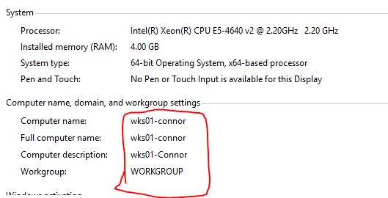

Then I created my own admin account on my Windows 10 server named Connor East. as is shown below:

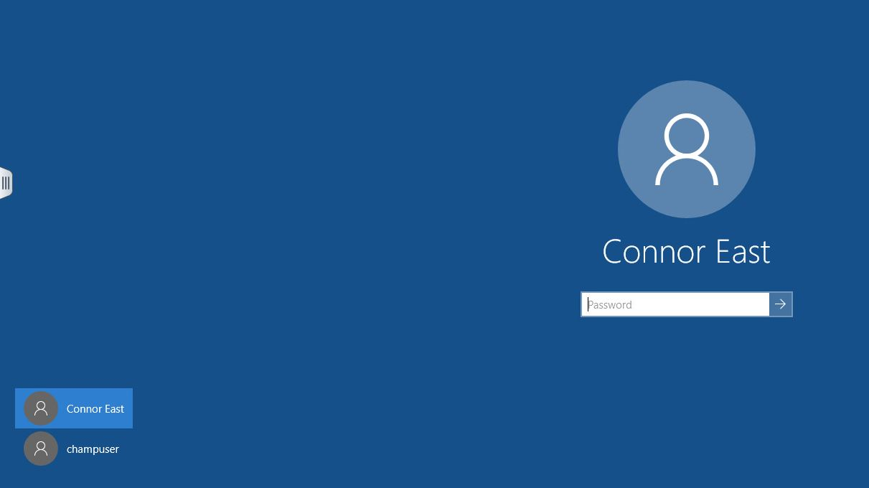

Once that had been completed I opened google chrome and made my way to 10.0.5.2 where I was met with the pfsense login page.

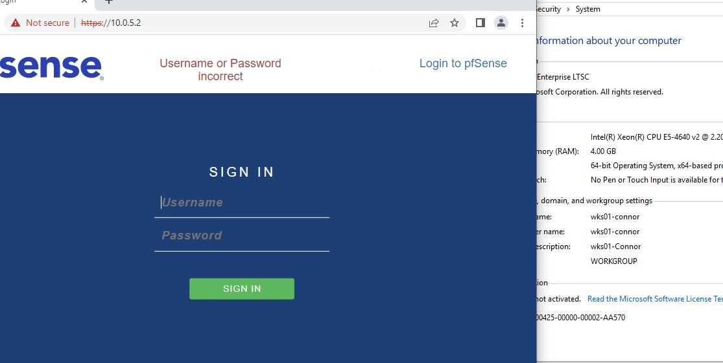

I inserted the Username “Admin” and password: “pfsense” in order to get into the pfsense setup page. I then clicked next twice before getting to the following page.

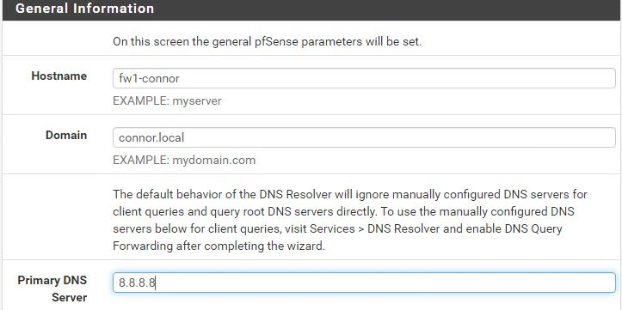

On this page I changed the hostname to “fw1-connor”, the domain name to “connor.local” and the primary DNS: 8.8.8.8. Next I clicked next 4 times before setting my Admin Password. Once that had been done I had successfully completed the pfsense configuration

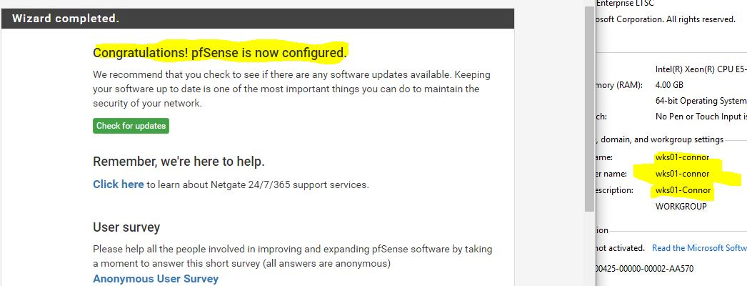

DELIVERABLES

***Deliverable 1***: Pinging Champlain.edu

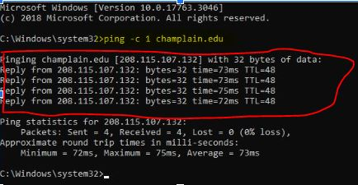

Above is an image of me pinging champlain.edu from my terminal by using the command “ ping -c 1 champlain.edu ” My device sent 4 packets and I received 4 packets back.

***Deliverable 2***: PowerShell

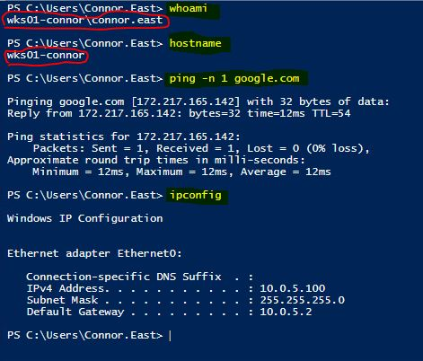

Above is an image that states my account name, the host device name, the ip configuration of my setup and information about pinging google.com. Items highlighted in yellow are the commands used in windows powershell while the items outlined in red are some of the answers relating to identity.

***Deliverable 3***: Navigating to Champlain:

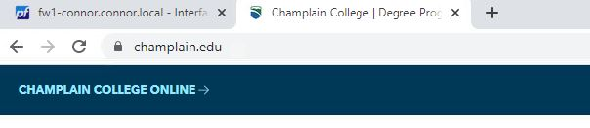

For this I simply went to chrome, typed in champlain, and clicked on the link associated with the school.

***Deliverable 4***: Tracert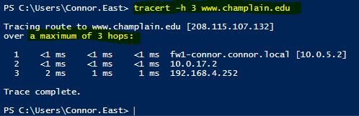

In order to use the tracert command with hops accounted for you must place “h 3” prior to the address. 3 being the theoretical amount of jumps you want to account for.

**Deliverable 5**: Terminology / Steps

Term 1: The Interface names em0 , em1 currently have no meaning to me. In other words I don’t actually know what if anything they stand for.

Term 2: “PPP” went over my head during the lab. I now know it stands fir point-to-point protocol.

Step 1: I was unfamiliar with the entirety of the firewall section. This section was discussed in previous classes however we never had the hands-on experience of setting something like this up.

Step 2:I need to re-familiarize myself with the windows command center as it took me way too long to get to the IP address of my VLAN.

*I had a lot of issues with this lab regarding my nervousness around being at a new school and using a new software “Vcenter/vSphere”. I will be working on this problem so it does not become a hindrance to the class.*

**Deliverable 6**: Submissions.

I have highlighted and or circled the relevant areas related to the snapshots for this assignment. I have also written short narratives after each snapshot that explains what is happening in the pictures.

***Deliverable 7:*** Tech Journal:

<https://github.com/ConnorEast/Tech-Journal.git>